Adding RegeX WL

On call check what is needed to scan into the system.

Lookup what is being called

Ex. 5526-1T3

Use BOM editor to find component

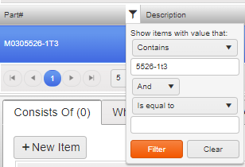

Check the Regex to see what is available or what needs to be added.

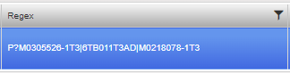

Edit the Regex

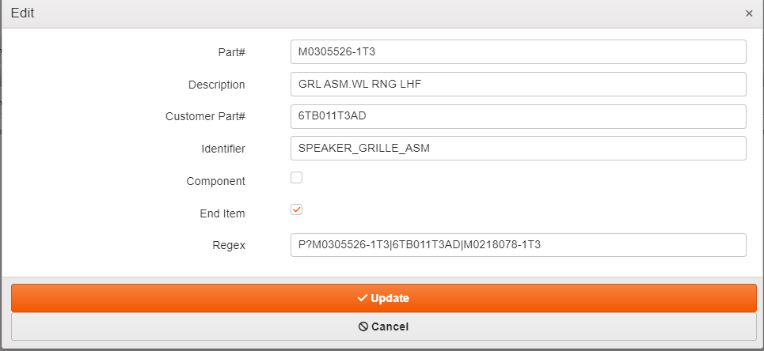

Adding a “|” between each part number “|” is compared to an And/OR so it lets any of those available to scan. Ex. M0305526-1T3, 6TB011T3AD, M0218078-1T3 are all available to be scanned and work for that component.

If you need to add another part number to the Regex, it would go as following: “|M0218079-1T3”

Once you have finalized what needs to go there, update and then Start/Stop the station for the rules to be implemented.

Try to scan and see if it works.

Additional STUFF I AM ADDING

Different symbols to add to regex to have it do more things for you.

“^” is the beginning of the string.

“$” is the end of the string

“.” Is a character count(It can be anything) (FCA....) would be FCAWL22, as long as the FCA matches it will accept anything after that.

“[0-9]” accepts any number from 0 to 9

“{10}” only accepts 10 characters

“(S” as long as it begins with S

“.+” accepts anything after the point it is called. (S0000061534&FCAWL21&M10005520-ANTEAK&01)

EX: “^(S[0-9]{10}&FCA....&M0400881-WT3&.+)$” “S0000061534&FCAWL21&M10005520-ANTEAK&01”

The “&” is a symbol that lets it become a character segment. If you want the 3rd segment count the &. it would pull “M10005520-anteak”

SQL STUFF:

After connecting to the server, the way to find the regex is similar to how you would through intelliworks.

Through partmaster you would type in your component you are looking for, then you would check the regex and edit the field if need be, using the same characters as you would for intelliworks.

EX:

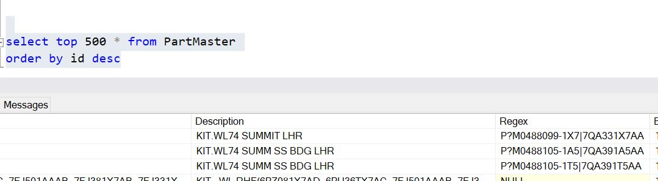

It looks similar to BOM editor, just a little less pretty.